

|  |
| --- |
| **GA Web Portal**  **FFS Genetic Testing Services Prior Authorization** |
| Provider User Manual - Version 1.0 |

**Contents**

Overview 3

Genetic Testing Request Guidelines and Restrictions 3

Genetic Testing PA Submission Instructions 3

Request Form 4

Provider Notifications 7

Change Requests 11

Provider Correspondence 16

**Revision History**

|  |  |  |  |
| --- | --- | --- | --- |
| Version | Date | Editor | Description |
| 1.0 | 11/01/2020 |  | First Published User Guide |

# Overview

Providers may submit a request for Genetic Testing Services and attach supporting documentation via the Medical Review Portal. Once a request is submitted, the request data is added to the Alliant Health Prior Authorization (PA) system and is available for review by Alliant Health staff. Once the decision has been rendered, Providers will receive a No-Reply email to notify them that a decision has been rendered. Additionally, should the prior authorization receive a second level denial decision, the member will receive a notification letter from Alliant Health Solutions.

**Genetic Testing Request Guidelines and Restrictions**

* The PA type for Genetic Testing is IL
* Rendering providers must have COS code of 230
* Only genetic testing procedure codes may be entered on the request (81401, 81403, 81404, 81405, 81406, 81408, 81479)
* Requests must have an effective/start date equal to or greater than the request date
* All requests may be submitted with a procedure start date up to 90 days in the future

**Genetic Testing PA Submission Instructions**

* Go to the **Georgia Web Portal** at [www.mmis.georgia.gov](http://www.mmis.georgia.gov/) and log in using your assigned user name and password.
* From the *Secure Home* page, select Prior Authorization→ Medical Review Portal; then Enter a New Authorization Request.

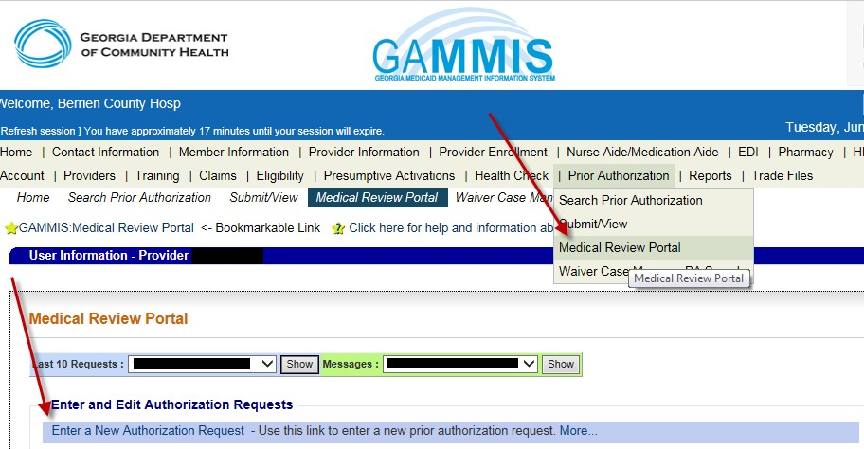

* Select the **Genetic Testing** link from the list of review types

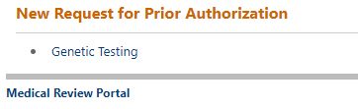

* On the next screen, the Provider ID is populated by the system based on portal login credentials.
* Enter the member’s Medicaid ID and clicks Submit.
* ***Request Form***

The Request Form is displayed with the provider information pulled into the PA request based on the provider’s portal credentials. The member information is pulled from MMIS and populated on the request.

* + Provider *Contact Information* is populated by the system. Provider would need to enter any information that is missing or incorrect.
  + Provider selects the *Date of Service, Admission Type, and Place of Service*
    - *Place of Service* will be 81-Independent Lab

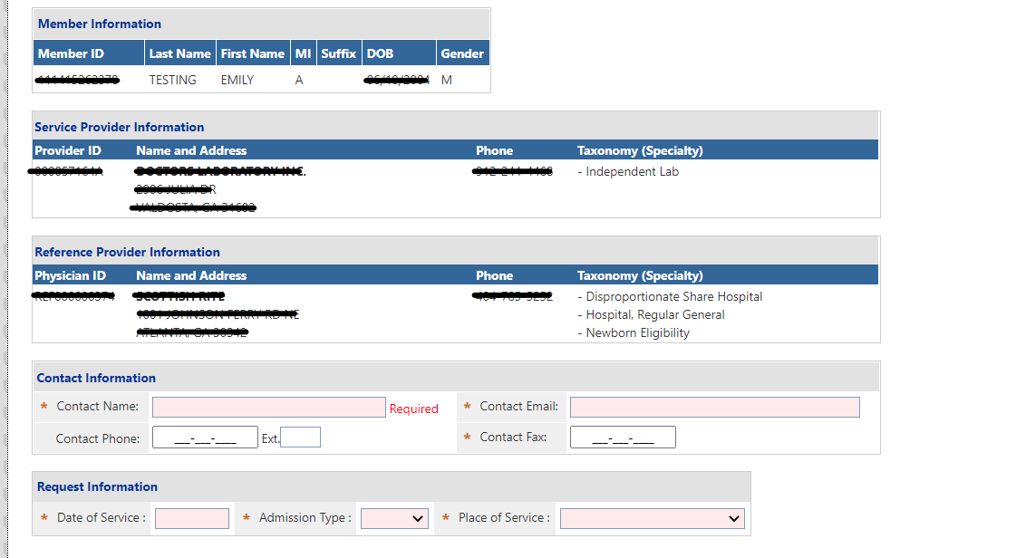

* + *Diagnosis Codes:* The Diagnosis table captures the diagnosis code, code description (system populated), diagnosis date, diagnosis type, and primary diagnosis indicator for each diagnosis code entered.
    - One primary diagnosis is required.
    - Click ADD to add the diagnosis code to the request
    - After the diagnosis code has been entered, the provider may select EDIT, to modify or delete the code.
    - *Procedure Codes*: The Procedures Table captures the procedure code, code description (system populated), date of service from and to dates, units requested, requested number of months per service.
    - Provider enters the procedure code; procedure from and to date, units requested and pick the test description from dropdown menu. NOTE—if provider needs to select a test description for each unit they request. Clicks Add.

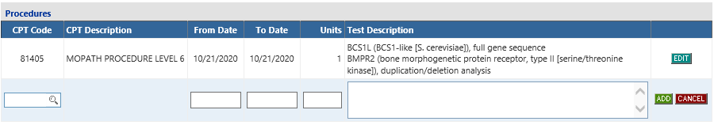

* Next, the provider will fill out any clinical information in the blanks provided on the PA form:

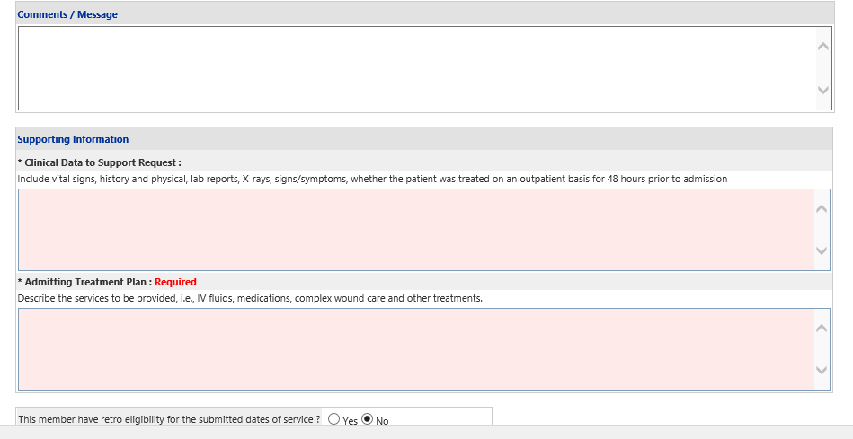

* + When all data is entered on the request form, click Review Request below the medications section to display the *Attestation Statement*. If the *Attestation Statement* does not display when Review Request is selected; or a message displays that ‘information is missing or incorrect’, scroll up the page to find what is missing or incorrect. ‘Required’ displays next to a data box when information is missing. Enter or correct the data, and then click Review Request again.
  + Click I Agree in response to the *Attestation Statement*

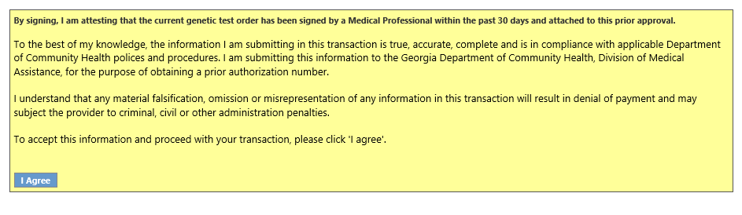

* Review the request. To change information entered, click Edit Request. Otherwise, click Submit Request.
* When the request is successfully submitted, the system displays the pending PA tracking number.

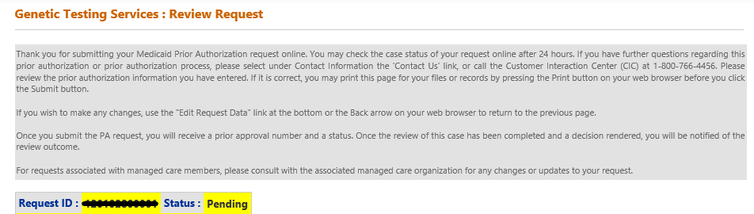

On this page, additional required documents may be attached under **Create an Attachment.** To attach a document, click Browse and select your file from your local system, the file name will appear in the text field. After verifying the correct file was selected, click Attach File to save the file to the Prior Authorization request. NOTE: The documents noted below.

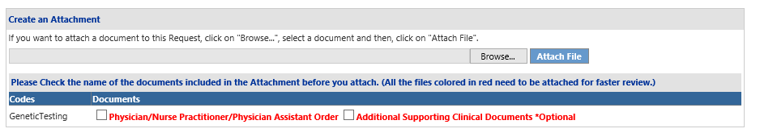

**Provider Notifications**

When a Genetic Testing Request is approved or denied, the requesting provider is notified via a no-reply email. In addition, when the PA is a 2nd level review/Reconsideration Request and the decision is denied, the parent or legal guardian of the member will receive a denial notification letter from Aliant Health Solutions. Providers can also review the case status and decision details from the *Medical Review Portal.*

***View Decision Details:***

* To view decision details, open the *Medical Review Portal* and click Search, Edit or Attach Documentation to Requests.

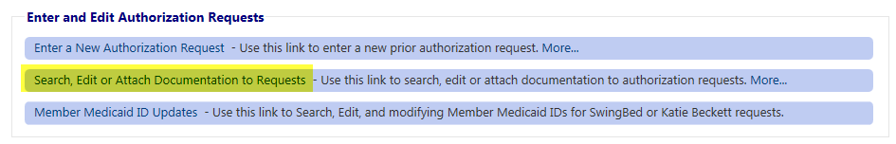

* Search for the Genetic Testing request by entering the ‘Request ID’ and clicking Search. Then click the PA that displays in the search results.

-OR-

* Open the *Medical Review Portal* and access the PA via the **PA Notifications** drop list. This list shows the **last ten** PA notifications. Select a PA number on the list and click Show.

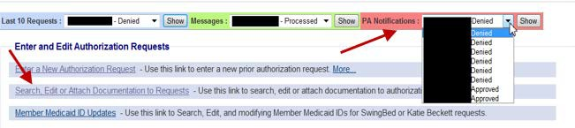

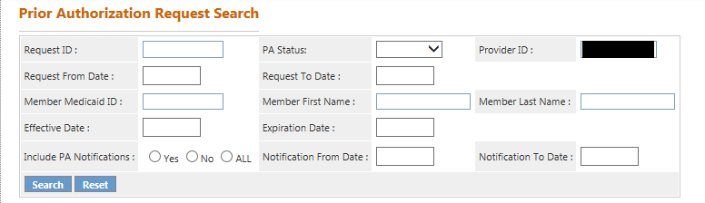

* No matter which route is used to view decision details, the PA opens on the *Review Request* page. The decision status and details can be viewed from the Review Request Screen.

**Reconsideration Request**

From the *Medical Review Portal*, providers may submit a request for reconsideration of the decision rendered on a Genetic Testing PA. When a Reconsideration Request is processed, a no-reply email and a ‘contact us’ message is sent to the provider. The notifications inform the provider that the reconsideration was processed and to check the *Provider Workspace* for details.

* ***Reconsideration Request Guidelines***
  + Reconsiderations are allowed when the PA has one or more procedure lines that are:
    - Approved but not for all units requested - requests must be submitted within **30** calendar days of the decision.
    - Peer consultant denied - requests must be submitted within **30** calendar days of the decision.
    - Tech Denied - requests must be submitted within **30**

calendar days of the decision.

* + Providers are required to attach additional documentation to support the reconsideration request. It is not necessary to re-submit all information sent with the original request but only the information to support the request for reconsideration.
* ***Reconsideration Submission Instructions***
  + Open the *Medical Review Portal* and select **Submit Reconsideration Requests**.

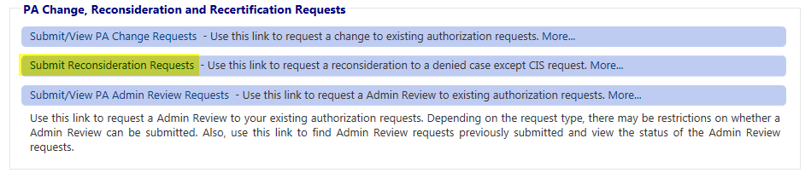

* + On the search page, enter the PA number in the Request ID’ box.
  + Click **Search.**
  + Click the request ID on the search results list to open the *Review Request* page.
  + Click **Enter Reconsideration Request** at the bottom of the *Review Request* page.

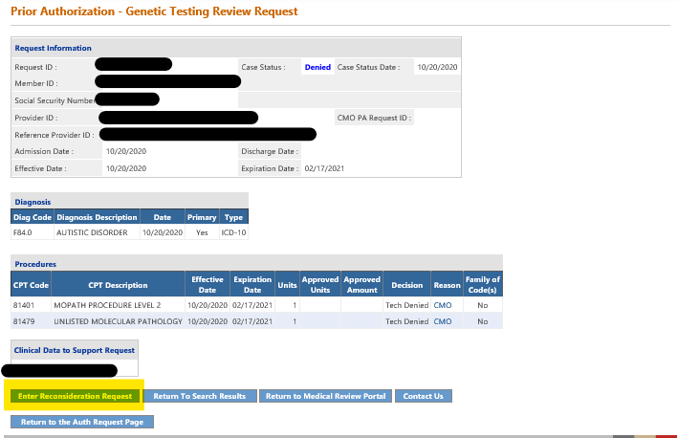

* + This opens the *Reconsideration Request Information* form.
  + At the top of the form, the contact information for the requesting provider is inserted by the system. Verify that the information is correct. If not correct, edit the information. This is important since a no-reply email is sent to the email listed on the reconsideration form when the reconsideration is processed.
* In the first text box, clearly describe what you wanted changed as a result of the reconsideration review, such as: the codes, dates of service, and the units required.
  + In the second text box, summarize additional clinical information that supports the request for reconsideration review and specifically addresses the need for the services requested. Since supporting documentation must be attached to the reconsideration, it is permissible to enter ‘See Attached’ in this box.

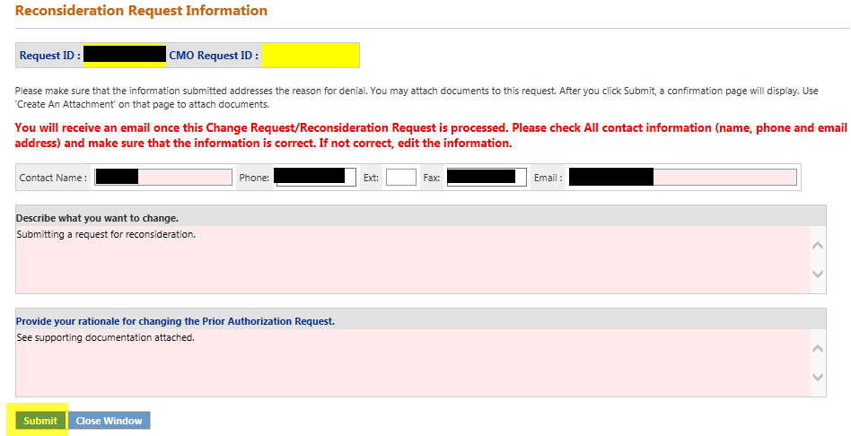

* + Click **Submit**.
  + If the submission is successful, a page displays confirming that the reconsideration has been entered successfully; and the attachment panel is available.

**Additional supporting documentation must be attached** at this point. Follow the same attachment procedures as described on page 7 of this manual.

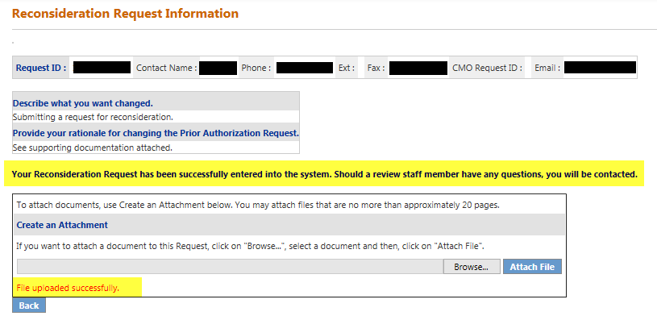

## Provider Correspondence

*Provider Correspondence* functionality allows Providers to submit questions to Alliant Health Solutions (AHS) reviewers via the *Medical Review Portal.* The workspace includes the following features to accommodate this type of correspondence:

* Contact Us
* Search My Correspondence
* Provider Messages

To learn more about the Provider Correspondence, please see the document titled ‘Provider Correspondence’ under the **Help & Contact Us** link on the portal.

## Submit/View Change Requests

From the *Provider Workspace*, providers may submit requests to change information on a PA; and may view change requests already submitted. Change requests are processed by Alliant reviewers and can be approved, denied or referred. When a Change Request is processed, a no- reply email and a ‘contact us’ message is sent to the provider. The notifications inform the provider that a change request was processed and to check the *Provider Workspace* for details. Providers can view the change request details, including the reviewer’s decision comments, by searching for and opening the PA *Review Request* page. The reviewer’s comments display in a tool tip (see highlighted below) made visible by holding the mouse pointer over the specific change request status.



* ***Change Request Submission Instructions***
* Open the *Provider Workspace* and select **Submit/View PA Change Requests**
* On the search page, enter the PA number in the ‘Request ID’ box.
* Click **Search**.
* Click the request ID on the search results list to open the *PA Review* Request page.

**Note**: When the *Review Request* page is opened for a request which does not meet the change request criteria, a message will appear at the top of the page indicating that a change request cannot be entered.

* Click **Enter Change Request** at the bottom of the page.
* 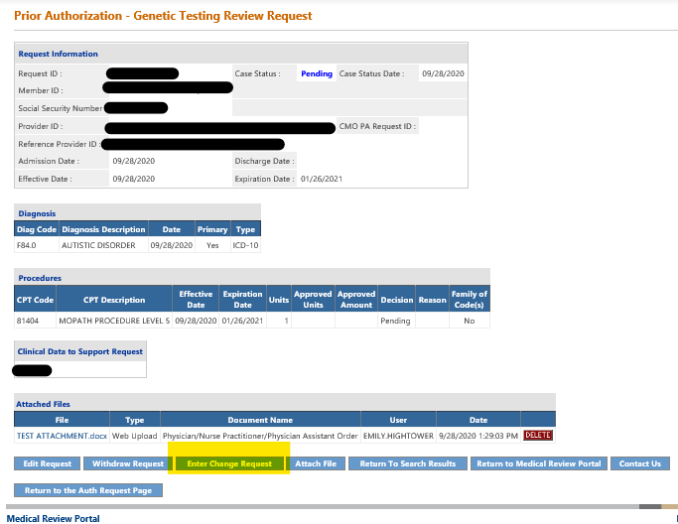
* The *Change Request Information* form opens.
* The provider’s contact information is inserted by the system. This information should be edited if not correct, since the no-reply email notification and contact are sent to the email address noted on the form.
* In the first box on the form, clearly describe what needs to be changed.
* In the next box, provide justification for the requested change(s).

Next, select one or more checkboxes from the ‘Rationale List’ corresponding to the change(s) requested. If none apply to the change requested, select ‘Other’.

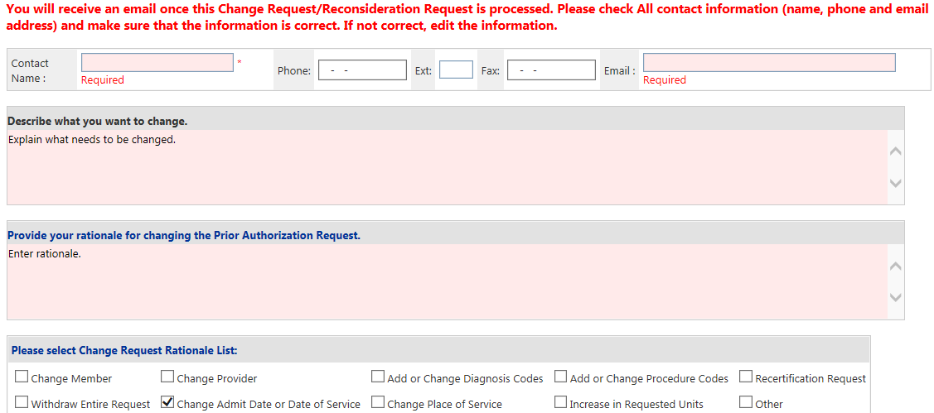



* Click **Submit** to submit the request.
* If the submission is successful, a window displays confirming that the change request has been entered successfully; and the attachment panel is available. Additional supporting documentation may be attached at this point.

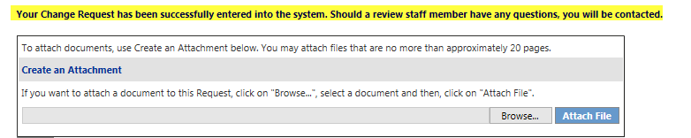

* **Additional supporting documentation must be attached** at this point.