Search for an Instructor

The Search for an Instructor function allows users to search for training program Instructors. The Instructor Search function consists of the three following search windows:

- Search for an Instructor
- Search for an Instructor - Initial Results
- Search for an Instructor - Detailed Results
How to Search for an Instructor Window
The Instructor Search window allows for the entry of search criteria. The user can search for all Instructors associated with a particular training program or can narrow the search to a specific Instructor by entering the Instructor's name or license number. At least one search criteria must be entered. To limit the search results, enter more specific criteria.

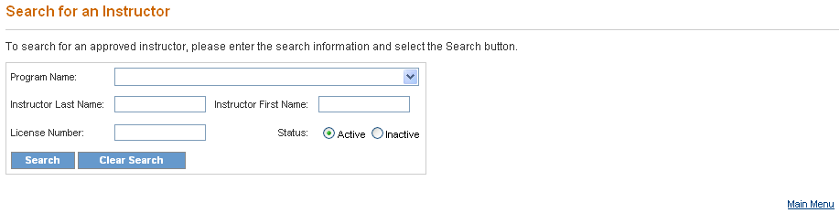
- To search for a specific Instructor enter the name of the Instructor in the Instructor Last Name and Instructor First Name fields, and/or enter the Instructor’s license number in the License Number field.
- To search for an Instructor associated with a particular training program, enter the name of the training program by clicking the down arrow in the Program Name field to display the Program drop down list, and then click on the name of the program.
- The default setting for Instructor status is Active. To limit the search to only inactive Instructors, click the Inactive status radio button.
- Once all search criteria are entered, click the Search button at the bottom of the window. The information entered is validated by the system. If an error message appears, make the corrections and click the Search button again.
- If there are no matches to the search criteria, a “0 records found” message is displayed. Search again by entering new search criteria, and then click the Search button at the bottom of the window.
- If the search is successful, the Search for an Instructor – Initial Results screen presents displaying all of the Instructors matching any of the search criteria.
- The screen also displays the total number of results found. To view the next set of results, click on “Next.” To return to the previous set of results, click on “Previous.”

