Train-the-Trainer Application (Log)

This function allows Providers and Training Program users to register for a Train-the-Trainer workshop.

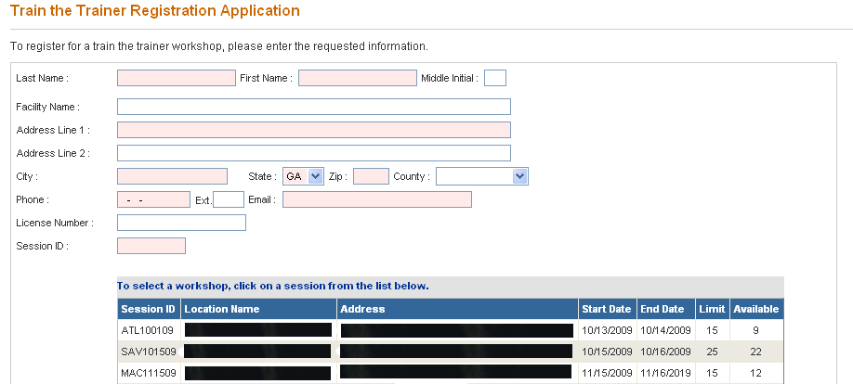
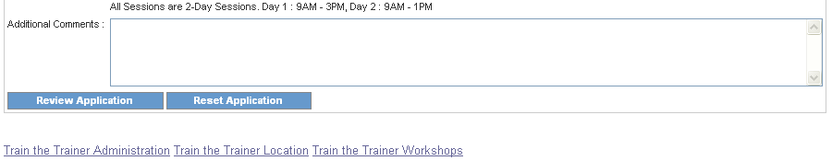

1. Enter the registrant’s last and first name in the Last Name and First Name fields. These fields are required.
2. Enter the registrant’s Facility Name, if applicable.
3. Enter the registrant’s address in the Address Line 1, Address Line 2, City, State, Zip Code fields. These fields are required.
4. Select the registrant’s county from the County drop down list.
5. Enter the registrant’s phone number in the Phone Number field. Phone numbers are entered as (nnn-nnn-nnnn). Enter the registrant’s email address in the Email field. Note that these fields are required.
6. Select the Train-the-Trainer session that the registrant would like to attend from the schedule by clicking the workshop. The Session ID field will populate based on the user selection. This field is required.
7. Add additional comments in the Additional Comments field.
8. To clear all fields and start over, click the “Reset Application” button. Otherwise, once the application has been completed, click the “Review Application” button. A read-only screen will present displaying all information entered into the TTT application.
9. If information is incorrect or needs to be changed, click the “Edit Application” button at the bottom of the page. Make necessary edits and click the “Review Application” button. If all information is correct, click the “Submit Application” button.
10. A message will be displayed confirming that the application has been processed and the time and location details of the workshop. In addition, an email message will be sent to the registrant confirming the details of the Train-the-Trainer workshop.
11. To return to the main menu, click the “Main Menu” link.

